<?php

namespace App\Test\Form;

use Datetime;

use App\Entity\Internships;

use Symfony\Bundle\FrameworkBundle\Test\KernelTestCase;

class InternshipsFormTest extends KernelTestCase{

 public function testNewInternships(){

$date=new Datetime();

 $interships=(new Internships())

 ->setOfferinternship('77')

 ->setPlaceintership('77')

 ->setStartinternship($date)

 ->setEndinternship($date)

 ->setLinkinternship('77');

 self::bootKernel();

 $error = self::$container->get('validator')->validate($interships);

 $this->assertCount(0,$error);

 }

}

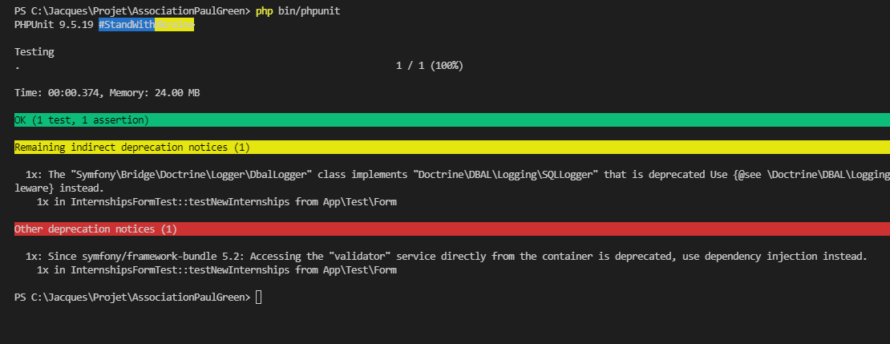

PS C:\Jacques\Projet\AssociationPaulGreen> php bin/phpunit

PHPUnit 9.5.19 #StandWithUkraine

Testing

. 1 / 1 (100%)

Time: 00:00.374, Memory: 24.00 MB

OK (1 test, 1 assertion)

Remaining indirect deprecation notices (1)

1x: The "Symfony\Bridge\Doctrine\Logger\DbalLogger" class implements "Doctrine\DBAL\Logging\SQLLogger" that is deprecated Use {@see \Doctrine\DBAL\Logging\Middleware} or implement {@see \Doctrine\DBAL\Driver\Middleware} instead.

1x in InternshipsFormTest::testNewInternships from App\Test\Form

Other deprecation notices (1)

1x: Since symfony/framework-bundle 5.2: Accessing the "validator" service directly from the container is deprecated, use dependency injection instead.

1x in InternshipsFormTest::testNewInternships from App\Test\Form

PS C:\Jacques\Projet\AssociationPaulGreen>

